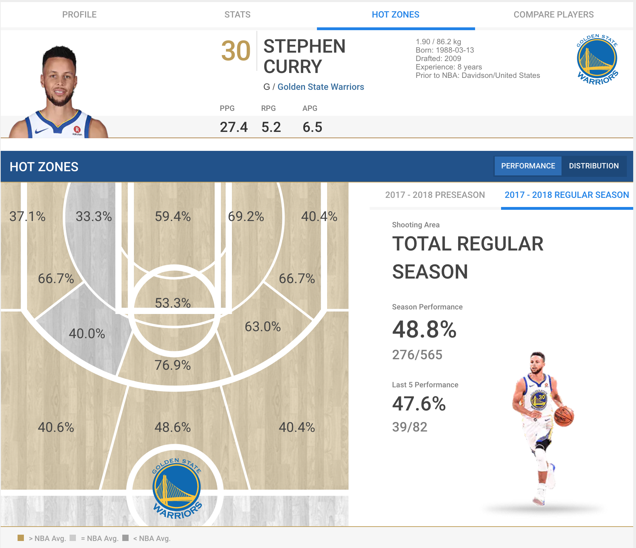

(Source: <https://uk.global.nba.com/players/hotzones/#!/stephen_curry>)

The hot zones chart of a NBA Player is the visualization that I like, especially the above web-based one. The reasons that I like it is as follows:

* It has an area map which can clearly give readers intuitional perception for shooting area in a NBA court.
* In the area map, readers can easily know one NBA player’s shooting performance in one specific court area by seeing the hit rate and the color of floor.
* Reader is able to move mouse cursor to any area to see Season Performance and Last 5 Season Performance in that area (including shooting made percentage and made number). After user move the mouse cursor out of the court area, the whole performance will appear like the above image shows (48.8% for Season Performance and 47.6% for Last 5 Performance)
* There are also team logo and player image in the chart, without them the chart will become a little bit tedious. With them, reader can imagine that Stephen Curry is dribbling in the court.

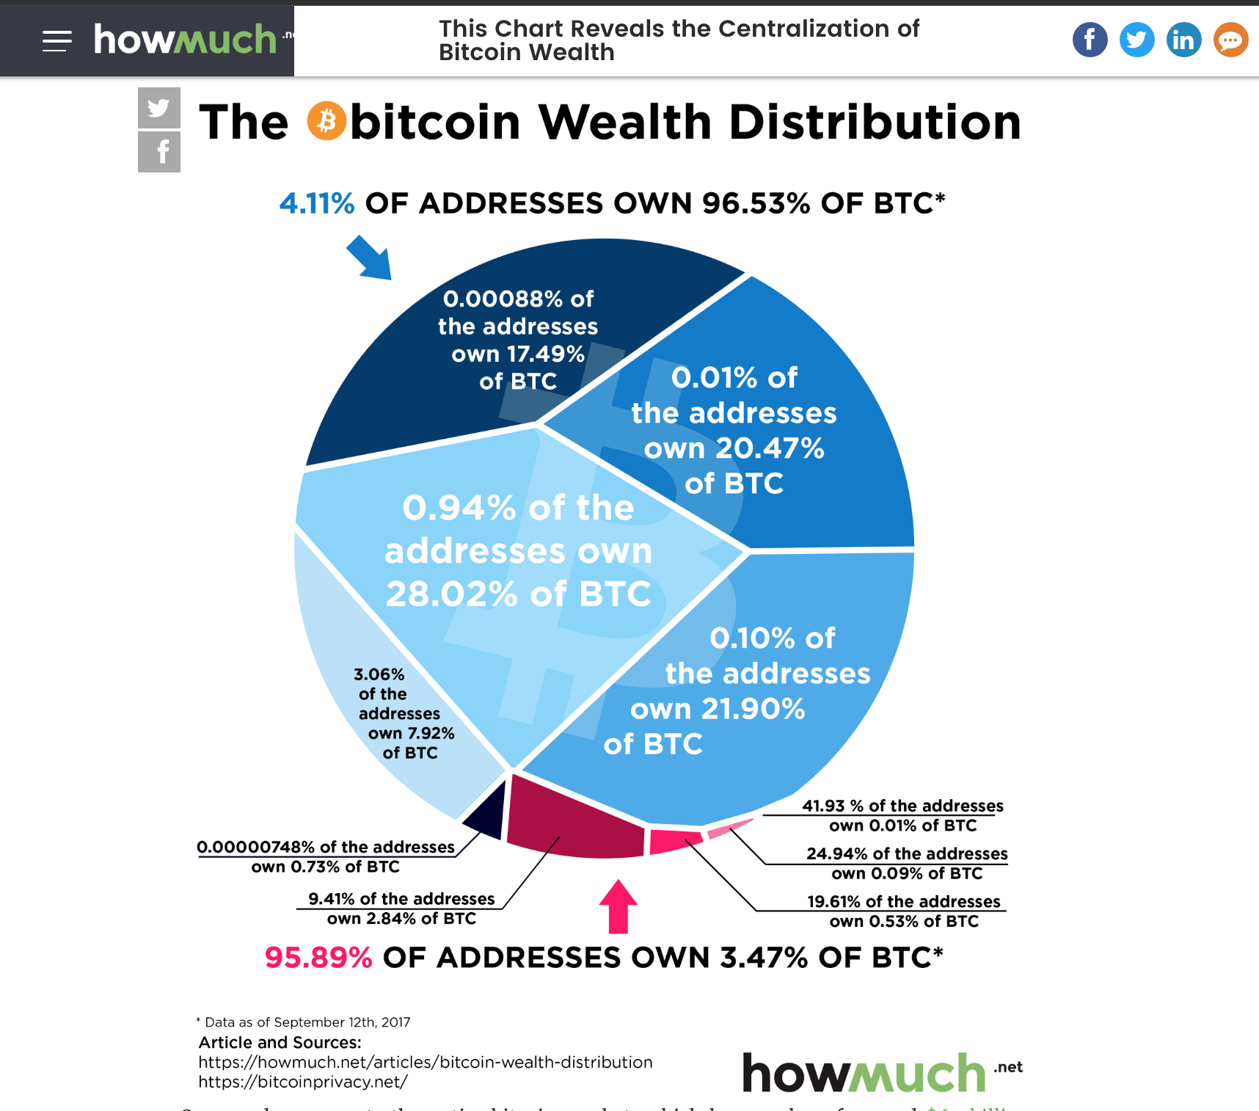

(Source: <https://howmuch.net/articles/bitcoin-wealth-distribution>)

I don’t like this bitcoin wealth distribution chart. It’s like a randomly shattered distribution. This graph wants to tell readers that **over 95% of all bitcoins in circulation are owned by about 4% of the market**. However, it takes me a lot of time to get that point. Instead, I can easily grasp the main point through two sentences in the graph: “4.11% of addresses own 96.53% of BTC” and “95.89% of addresses own 3.47% of BTC”. The reasons that I don’t like it is as follows:

* The distribution of the graph seems like meaningless, which increases the difficulty to understand this graph.There are so many areas with complicated percentages in each area, and areas at the bottom of the graph are so small with small words, which needs reader do a hard math to get the point.
* It is observed that writer wants to use similar color to classify different areas, and use the color of words to create relation with those areas, like 95.89% represents those three small red areas at the bottom of the graph and 4.11% represents the top five blue areas. However, it is difficult to establish relation between 95.89%, 4.11% and those areas, because the color of those areas are slightly different from the color of 95.89%, 4.11% (although readers may know that writer wants to use the intensity of color to represent the percentage of BTC), and it takes readers minutes to calculate the percentage sum of those areas to prove that relation.

Pie graph can only clearly represent the distribution of one kind of data, but there are two distributions in this graph. So, I’d like to use two bar graphs to represent it, as shown in the following, which I think can clearly show the main idea that “**over 95% of all bitcoins in circulation are owned by about 4% of the market**.”

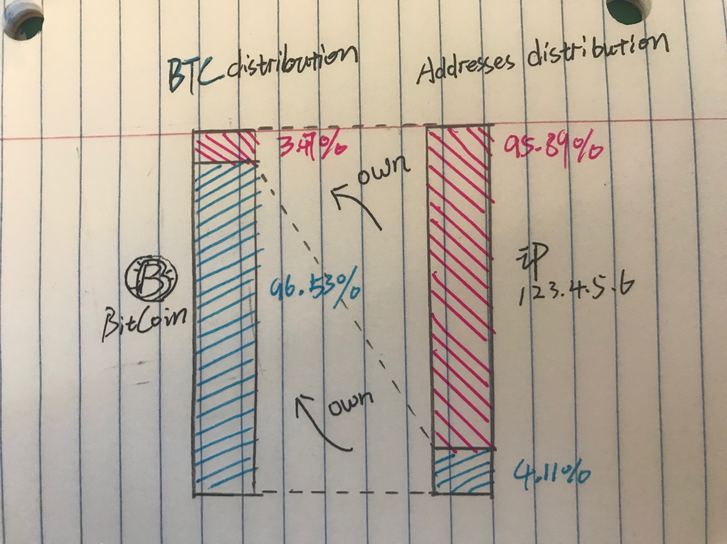

(The different parts in original pie graph is meaningless, I combine them into two parts)

In addition, cumulative distribution graph can also be used to improve original pie graph.

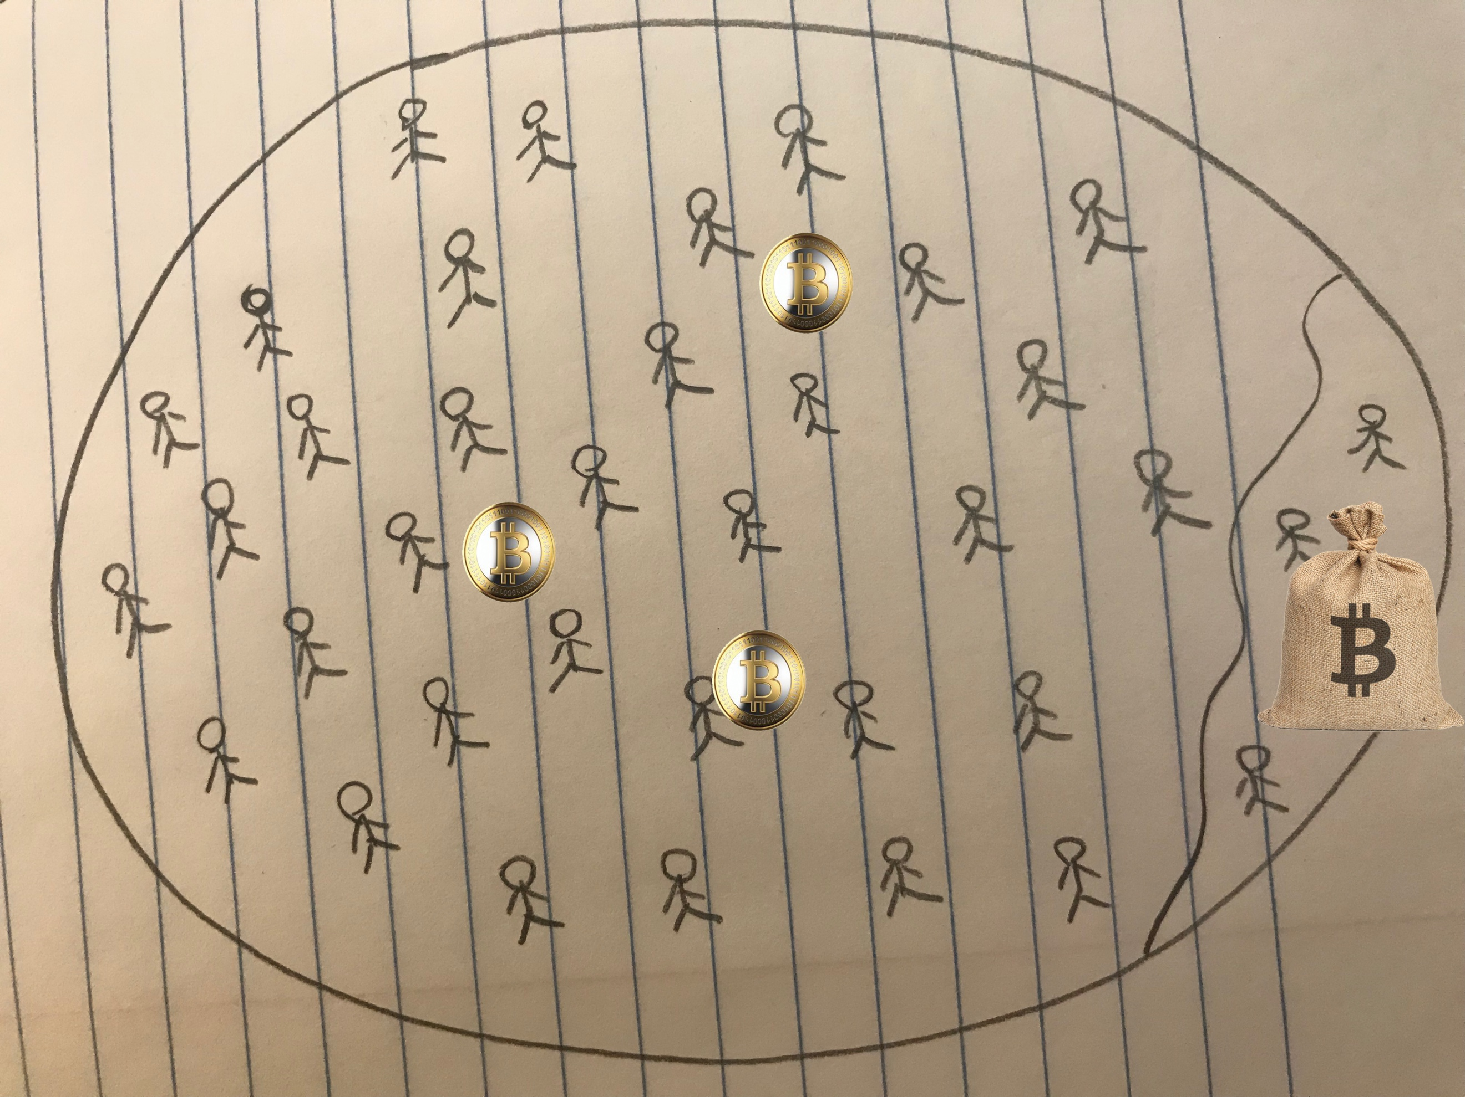

95.89% addresses

4.11% addresses

(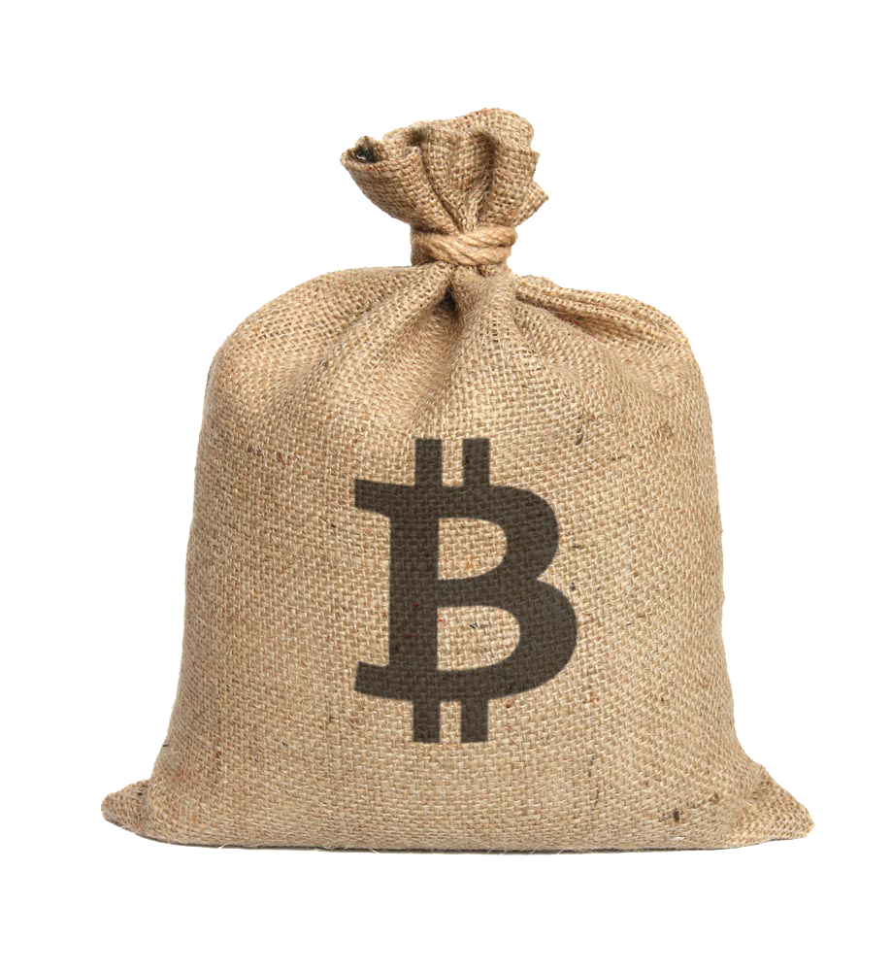Holds 96.53% bitcoins and three  represent 3.47% bitcoins)

Cumulative distribution graph can also be used for this situation.